ONLNE HOSPITAL BIRTH CERTIFICATE MANAGEMENT SYSTEM

PERSONAL DETAILS
PROJECT TITLE :ONLINE BIRTH CERTIFICATE MANAGEMENT SYSTEM
PRESENTER :NACHIBATI B. BYLINE
INDEX NUMBER :4050240
DEPARTMENT :COMPUTING INFORMATICS
COURSE :DIPLOMA IN INFORMATION COMMUNICATION TECHNOLOGY
COURSE CODE :2920/308
CENTER NUMBER :4050240142
CENTER NAME :PC KINYANJUI TECHNICAL TRAINING INSTITUTE
YEAR :2026
SERIES :MARCH \ APRIL SERIES
SUPERVISOR :CORNELIUS MUSYOKI
SUBMITTED TO :THE KENYA NATIONAL EXAMINATION COUNCIL

DECLARATION
I declare that this is my own designed system, from my own creativity and contain ideas that no other student have presented it ever.

Student: NACHIBATI B. BYLINE
Signature……….. Date………
Supervisor: CORNELIUS MUSYOKI
Signature……….. Date……….

DEDICATION
I wish to dedicate this publication to my friends and family members who have been very supportive financially and with ideas all through during the system development period.

ACKNOWLEDGEMENT
I wish to acknowledge God first, for he has favored me through that period of developing the system. He granted me his knowledge, wisdom and strength throughout the period. I would also love to thank my parents for the financial and emotional support, friends for giving me more ideas and also my project teacher who trained me how to code, to design and develop a working system. May the Lord God bless them all.

Contents
DECLARATION .......................................................................................................................................... i
DEDICATION ............................................................................................................................................. ii
ACKNOWLEDGEMENT ......................................................................................................................... iii
CHAPTER ONE ......................................................................................................................................... 1
1.0 Introduction ....................................................................................................................................... 1
1.1 Background Information .................................................................................................................. 1
1.2 Problem Statement ............................................................................................................................ 2
1.3 OBJECTIVES ................................................................................................................................... 3
1.3.1 General Objectives ..................................................................................................................... 3
1.3.2 Specific Objectives ..................................................................................................................... 4
1.4 Research Questions ........................................................................................................................... 4
1.5 Significance of the study ................................................................................................................... 5
1.6 Conceptual and theoretical framework .......................................................................................... 6
1.7 Scope of the study .............................................................................................................................. 8
2.0 CHAPTER TWO ............................................................................................................................ 9
2.1 Literature Review ............................................................................................................................. 9
2.2 Discussion of the existing system ................................................................................................... 10
2.3 Description of the proposed system. .............................................................................................. 12
2.4 Description of unique features of proposed design ...................................................................... 13
3.0 CHAPTER THREE ............................................................................................................................ 14
3.1 Methodology .................................................................................................................................... 14
3.2 Defining the Nature of the Activity ................................................................................................ 14
3.3 Preparations of Drawings or Research Design ............................................................................. 15
3.3.0 Flow Charts .............................................................................................................................. 15
3.4 Production of Components, Service or Data Collection, Model or Simulation ......................... 17
3.4.0 Input Design Discussion........................................................................................................... 17
3.4.1 User Signup Form .................................................................................................................... 17
3.4.1 Admin Login ............................................................................................................................. 17
3.4.2 User Login Form ...................................................................................................................... 17
3.4.3 Hospital Signup Form .............................................................................................................. 18
Output Design Discussion ..................................................................................................................... 20
REPORTS .............................................................................................................................................. 20
3.4.5 Admin Dashboard .................................................................................................................... 20
3.4.6 User Notification Report.......................................................................................................... 20
3.4.7 Notifications List Report ......................................................................................................... 21
3.5 Testing of Analysis of Components or Hypothesis ....................................................................... 21
4.0 CHAPTER FOUR ............................................................................................................................... 22
4.1 Findings, Data Analysis, Conclusions and Recommendations .................................................... 22
4.3 Evidence of Data Analysis Using Tables, Charts and Graphs ..................................................... 22
4.3.1 Representation of Data Collected ........................................................................................... 23
4.4 Conclusions Based on Research Findings ..................................................................................... 23
4.5 RECOMMENDATIONS: Related to the findings and demonstrating resolution identified
gaps. ........................................................................................................................................................ 24 REFERENCES .......................................................................................................................................... 25
APPENDICES ........................................................................................................................................... 26
PERMISSION LETTER ...................................................................................................................... 26
QUETIONNAIRES ..................................................................................................................................... 27
To the Users ....................................................................................................................................... 27
To the center’s staff members .......................................................................................................... 29
Project Schedule ........................................................................................................................................ 30
CODES ................................................................................................................................................... 31

CHAPTER ONE

1.0 Introduction
In today’s digital age, organizations and institutions responsible for managing birth certificates face numerous challenges, including manual paper work, lengthy processing times and security concerns. My proposed system which is an online hospital birth certificate management system aims to address these issues by providing a comprehensive and user-friendly platform for efficient birth certificate management.
The objective of this project is to design and develop a robust online system that simplifies the process of issuing, tracking and managing birth certificates. By leveraging modern technologies and intuitive user interface, the system aims to streamline administrative tasks, reduce manual errors and enhance data security, ultimately improving the overall experience for both administrators and users.
The proposed system will offer a range of functionalities tailored to the unique needs of the users. Users will be able to access the system securely, perform various actions based on their roles that is, either as an administrator or parent and have complete control over the lifecycle of birth certificates. From initial registration to certificate issuance and record maintenance, the system will provide a centralized platform to manage the entire process seamlessly.

1.1 Background Information
Birth certificates are vital documents that serve as legal proof of a person's birth and identity. They play a crucial role in various aspects of life, including citizenship, education, healthcare, and employment. However, the traditional methods of managing birth certificates often involve manual paperwork, lengthy processing times, and inherent risks of errors and security breaches.
In an increasingly digital world, organizations and institutions responsible for issuing and managing birth certificates are recognizing the need for more efficient and secure systems. An online birth certificate management system provides a modern solution to overcome the limitations of traditional paper-based processes, offering numerous benefits to both administrators and users. Currently, many organizations struggle with manual data entry, physical storage limitations, and the need for multiple copies of birth certificates. These challenges often result in delays, inefficiencies, and increased administrative workload.
Furthermore, the risk of misplacing or damaging physical documents poses significant concerns for the integrity and accessibility of birth records.
The introduction of an online birth certificate management system aims to address these challenges by leveraging technology to streamline the entire process. By transitioning from paper-based records to a secure digital platform, organizations can improve their efficiency, accuracy, and data management capabilities. Additionally, users will benefit from a simplified and expedited application process, reduced paperwork, and enhanced convenience.
With the implementation of this system, administrators will experience improved productivity and reduced administrative burden. They will be able to process birth certificate applications more efficiently, track the progress of each request, and generate accurate reports as needed. Moreover, the system will provide a centralized repository for birth records, ensuring easy retrieval and maintenance of essential data. For parents and individuals seeking birth certificates, the online system will offer a convenient and user-friendly experience. They will be able to submit applications online, track the status of their requests in real-time, and receive digital copies of the birth certificates quickly. This streamlined process will save time and effort, ultimately enhancing customer satisfaction.

1.2 Problem Statement
The current process of managing birth certificates presents numerous challenges and limitations that hinder efficiency, accuracy, and data security. One of the major issues is the manual and time-consuming nature of the existing paper-based system. This outdated method requires manual data entry, physical document handling, and extensive paperwork, resulting in labor intensive processes that are prone to errors and delays in issuing birth certificates.
Furthermore, the lack of a centralized and automated system leads to inefficient tracking and record maintenance. Without a unified platform, it becomes difficult to track the status of birth certificate applications, causing confusion and potential delays in processing. Moreover, the absence of systematic record maintenance and physical storage limitations pose challenges in retrieving and managing birth records effectively.

Security risks and data breaches are also major concerns in the current system. Physical birth certificate documents are vulnerable to loss, damage, or unauthorized access, compromising the security and privacy of sensitive information. In the absence of proper safeguards and access controls, there is an increased risk of identity theft, fraud, or misuse of personal data. The reliance on physical documents further limits accessibility and convenience, particularly for individuals who require expedited services or reside in remote locations. The lack of online accessibility hampers convenience and increases the administrative burden on both applicants and staff involved in the birth certificate management process.
In addition, the absence of a centralized platform for birth certificate management leads to ineffective collaboration and communication between administrators, staff, parents, and government officials. This fragmented communication affects the timely processing of applications, increases the likelihood of errors, and diminishes the overall user experience.
To address these pressing problems, the development of an online birth certificate management system is essential. By digitizing the process, automating workflows, and implementing robust security measures, the system can streamline administrative tasks, enhance data accuracy, and ensure secure access to birth certificates. It will provide a user-friendly interface for applicants, centralized record management for administrators, and advanced reporting functionalities for data-driven decision-making. Such a system will revolutionize the management of birth certificates, improving efficiency, accessibility, and security for all stakeholders involved.

1.3 OBJECTIVES

1.3.1 General Objectives
The general objective of the online birth certificate management system is to streamline and modernize the process of registering and obtaining birth certificates, enhancing efficiency, accessibility, and convenience for individuals while reducing the need for physical visits to government offices. By maintaining a comprehensive and reliable record of individuals' dates of birth, the system aims to expedite the registration process and enable online issuance of birth certificates, thereby saving significant time and effort for both the applicants and the government authorities involved.

1.3.2 Specific Objectives
- To maintain a good record of date of birth of people.
- It will help eliminate the need for physical visits to government offices, saving time and effort.
- To provide easier registration of date of birth and getting the certificate online which saves lots of time.
- To make the registration process faster for the birth certificates

1.4 Research Questions
- What are the specific pain points and challenges faced by organizations/institutions in managing birth certificates using traditional paper-based systems?
- What are the key functionalities and features required in an online birth certificate management system to address the identified challenges effectively?
- What are the best practices and industry standards for data security and privacy in online systems handling sensitive personal information like birth certificates?
- How can user experience principles be applied to design a user-friendly interface for the online birth certificate management system, ensuring ease of use and accessibility for different user roles?
- How can the online birth certificate management system be designed to ensure scalability, performance, and reliability, particularly considering potential increases in the volume of birth certificate applications over time?
- What are the legal and regulatory requirements that need to be considered in the development and deployment of the online birth certificate management system, such as data protection laws and compliance with government regulations?
- What are the potential risks and vulnerabilities associated with an online system for managing birth certificates, and how can these risks be mitigated?
- How can analytics and reporting capabilities be incorporated into the system to provide administrators with real-time insights, track performance metrics, and generate comprehensive reports on birth certificate applications and records?
- What are the expected benefits and impacts of implementing an online birth certificate management system?

1.5 Significance of the study
The proposed study on the development and implementation of an online birth certificate management system holds significant importance for various stakeholders involved. Firstly, it aims to enhance efficiency and streamline administrative processes by reducing manual paperwork, data entry errors, and processing delays. By providing insights into workflow optimization and task automation, the study will enable organizations to achieve time and cost savings. A key aspect of the study is improving data accuracy and integrity. Through the digitization of the birth certificate management process, it will ensure accurate data entry, eliminate the risk of misplacing physical documents, and facilitate systematic record maintenance. This will enhance the integrity and reliability of birth records, reducing discrepancies and providing a trustworthy source of information.
Data security and privacy are paramount in the digital age, and the study will focus on implementing robust security measures, encryption protocols, and access controls. By addressing data security concerns, organizations can assure individuals that their personal data is secure and build trust in the system. An online birth certificate management system will also significantly increase accessibility and convenience for individuals. Regardless of their location or time constraints, individuals will have convenient access to their birth certificates. The study will explore user-friendly interfaces, responsive design, and accessibility standards to ensure that the system caters to a wide range of users, including those with disabilities.
Moreover, the study will integrate robust reporting and analytics capabilities into the system. This will empower administrators to generate real-time insights, track performance metrics, and make data-driven decisions to improve processes, allocate resources effectively, and identify areas for improvement. Compliance with legal and regulatory requirements is of utmost importance, and the study will ensure adherence to data protection laws, privacy regulations, and government mandates associated with managing birth certificates.
Scalability and adaptability are essential considerations, and the study will assess the system's capacity to handle potential increases in application volume and accommodate changing requirements.
This ensures that the system can grow alongside organizational needs and adapt to future technological advancements. Finally, the study will prioritize the user experience, aiming to create a user-friendly and intuitive interface. By focusing on user-centric design principles, the system will enhance user satisfaction, reduce frustration, and encourage greater utilization and acceptance by both administrators and applicants.
Overall, the study on the development and implementation of an online birth certificate management system encompasses crucial aspects such as efficiency, data security, accessibility, compliance, scalability, and user experience. Its findings and recommendations will shape the future of birth certificate management, benefiting stakeholders and ensuring a more streamlined, secure, and user-friendly process.

1.6 Conceptual and theoretical framework
Conceptual Framework:
The conceptual framework for an online birth certificate management system revolves around the core objective of establishing a streamlined and efficient process for managing birth certificates electronically. At its heart, the system aims to digitize and automate the entire birth certificate issuance process, ensuring convenience, accuracy, and security for individuals and administrative authorities involved.
The user interface of the system will be designed to be intuitive and user-friendly, catering to individuals, parents, hospitals, and government officials. It will offer easy navigation, seamless data input, and quick retrieval of birth certificate-related information. This user-centric design approach will prioritize ease of use and accessibility. To ensure the integrity of the system, individuals will be required to register their personal information and authenticate their identities securely. This registration and authentication process may involve the submission of relevant identification documents and verification mechanisms, ensuring the accuracy and legitimacy of the provided data.
The birth certificate application component will enable individuals or parents to submit their applications electronically. Users will input necessary details such as the child's name, parents' information, date and place of birth, and other relevant data. The system will validate this information and initiate the processing workflow.
To validate the authenticity of submitted documents, such as identification proofs, marriage certificates, or medical records, the system will integrate with relevant government databases or authorities. This integration will enable automated verification processes and manual review by authorized personnel, ensuring the accuracy and reliability of the provided information.
Once all necessary information and documents have been verified, the system will generate a digital birth certificate. The generated certificate will include unique identification numbers, official seals, and relevant details. Special attention will be given to the security and integrity of the generated certificates, protecting them from unauthorized alterations. The system will also provide convenient delivery and access options, allowing users to securely download the digital birth certificates. This feature will enhance accessibility and eliminate the need for physical document handling.
Theoretical Framework:
The theoretical framework for the online birth certificate management system draws upon principles and concepts from information systems, data management, and process automation. It incorporates theories and methodologies to ensure an efficient and secure system.
The design of the system will be guided by principles of information systems, focusing on effectively capturing, storing, retrieving, and disseminating birth certificate-related data. This will involve leveraging database management systems, data models, and secure communication protocols to ensure data integrity and confidentiality throughout the system.
Workflow automation will be a key aspect of the system, incorporating concepts from workflow management to automate and optimize the birth certificate application and processing workflows. By automating these workflows, the system will enhance efficiency, reduce errors, and ensure consistent adherence to standardized processes, resulting in a streamlined and effective system.
To ensure the accuracy and legitimacy of the provided data, the system will integrate mechanisms for data verification and validation. This will involve the implementation of data validation rules, cross-checking with external sources, and manual review processes. By employing these methods, the system will ensure the reliability and quality of the birth certificate information stored within it.
Security and privacy principles will be embedded in the system's design to protect the confidentiality, integrity, and availability of sensitive data. This will involve employing encryption techniques, secure data transmission protocols, audit trails, and user consent mechanisms. These measures will safeguard personal information and mitigate risks associated with data breaches or unauthorized disclosures, ensuring the security and privacy of individuals' data. The system will also prioritize usability and user experience principles. User-centric design approaches will be employed to create an intuitive and user-friendly interface. This will involve considering factors such as ease of navigation, clear instructions, and responsive design, ensuring that users can interact with the system effortlessly and have a positive user experience.
In summary, the theoretical framework for the online birth certificate management system encompasses principles from information systems, data management, and process automation. It incorporates theories and methodologies to ensure efficient data handling, secure processes, accurate information, and a user-friendly interface. By applying these principles, the system aims to provide a robust and effective platform for managing birth certificates electronically.

1.7 Scope of the study
The scope of the study entails the development, implementation, and evaluation of an online birth certificate management system. The system will be designed with a user-friendly web based interface, catering to individuals, parents, hospitals, and government officials. The backend infrastructure will be developed to support data storage, processing, and retrieval, while integrating with existing government databases for verification and validation of birth certificate related information. Security measures, including secure authentication and access control, will safeguard sensitive data. The birth certificate application process will be streamlined and automated, incorporating data validation, workflow management, and generation of digital certificates. Document verification will be carried out through integration with relevant government databases and automated processes, ensuring accuracy and legitimacy.
Data security and privacy will be prioritized through encryption techniques, secure data transmission, and adherence to regulations. Multiple delivery options will be provided, including secure digital downloads and physical copies. Authorized users will have access to a centralized database, and access control measures will be implemented. Usability testing, performance evaluation, and stakeholder feedback will guide refinements and improvements to the system.

2.0 CHAPTER TWO

2.1 Literature Review
The management of birth certificates is a crucial administrative process that plays a vital role in maintaining accurate records and facilitating various legal and social activities. Traditional paper-based systems have been the norm for managing birth certificates, but they often suffer from inefficiencies, security vulnerabilities, and limited accessibility. The emergence of online technologies offers an opportunity to address these challenges and improve the overall management of birth certificates. This literature review examines existing research and studies related to online birth certificate management systems to provide a comprehensive understanding of the current state of the field and identify gaps that need to be addressed in the development of an effective online birth certificate management system. Several studies highlight the importance of process automation in streamlining birth certificate management. For instance, Smith et al. (2018) emphasized the need for automated workflows to reduce manual errors, eliminate redundancies, and expedite the application and issuance process. Similarly, Jones and Lee (2019) explored the benefits of electronic data capture and digital form submission in enhancing efficiency and reducing processing time.
Ensuring the security and privacy of sensitive personal information is critical in any online system. Studies such as Wang et al. (2020) and Chen and Lin (2019) discuss the significance of implementing robust security measures, including encryption protocols, access controls, and secure data transmission, to safeguard personal data and prevent unauthorized access or data breaches. Furthermore, legal and regulatory compliance in terms of data protection and privacy requirements are highlighted by Kim and Lee (2017) as a crucial aspect of online systems.
A user-centric approach is essential in the design and development of an effective online birth certificate management system. Studies by Johnson and Smith (2018) and Liu and Chen (2020) emphasize the importance of creating a user-friendly interface that caters to individuals with varying levels of digital literacy. Additionally, the system should be accessible to individuals from diverse backgrounds, including those with disabilities and those residing in remote areas (Johnson et al., 2021).
The integration of online birth certificate management systems with existing government databases and systems is crucial for data accuracy, record linkage, and information exchange.
Studies such as Park et al. (2019) and Gupta and Kumar (2020) explore the benefits of interoperability and data integration, enabling seamless data sharing across various government agencies and departments. While existing literature provides valuable insights, there are still several areas that require further exploration. For example, studies focusing on the scalability and adaptability of online birth certificate management systems to handle increased application volumes and evolving technological requirements are limited. Additionally, research on the use of emerging technologies such as blockchain for secure and decentralized birth certificate management is relatively sparse.
This literature review highlights the significance of online birth certificate management systems in improving efficiency, enhancing data security and privacy, ensuring user accessibility, and integrating with existing government systems. It also identifies research gaps that need to be addressed, emphasizing the need for further exploration of scalability, adaptability, and the utilization of emerging technologies. By integrating the findings from existing research, this review provides a foundation for the development and implementation of an effective online birth certificate management system, contributing to improved administrative processes and enhanced service delivery.

2.2 Discussion of the existing system
The existing online birth certificate management system has undoubtedly brought about significant improvements in the efficiency, accuracy, and accessibility of birth certificate issuance and management processes. However, there is still room for improvement to address certain limitations and enhance user convenience. One key aspect that requires attention is the ability for users to download and print birth certificates directly from the online system, thereby eliminating the need for paper-based certificates and reducing the over-crowding of clients at the government Huduma Centers.
Currently, while the online system allows for the electronic submission and processing of birth certificate applications, the final birth certificates are often sent to the Huduma Centers for physical collection. This approach introduces additional challenges, such as increased footfall and long waiting times at these centers. By enabling users to download and print birth certificates directly from the online system, these challenges can be mitigated.
Allowing users to download and print birth certificates has several advantages. Firstly, it eliminates the need for individuals to physically visit the Huduma Centers, reducing the overcrowding of clients and alleviating the burden on the staff. This streamlining of the process can significantly enhance the overall efficiency of the system and improve the user experience.
Secondly, eliminating the reliance on paper-based certificates can lead to cost savings and environmental benefits. The production and storage of physical certificates require resources and space. By transitioning to digital certificates that can be easily downloaded and printed by users, the need for printing, distribution, and storage of paper documents is significantly reduced. This aligns with the broader goal of promoting sustainability and reducing the carbon footprint.
Furthermore, the ability to download and print birth certificates offers individuals greater convenience and flexibility. Users can access their birth certificates whenever needed, without being restricted by the operating hours or geographical limitations of the Huduma Centers. This is particularly beneficial for individuals residing in remote areas who may face challenges in accessing physical service centers.
To implement this improvement, the online birth certificate management system should incorporate secure download and printing functionalities. It should ensure that the downloaded certificates maintain the necessary security features and integrity, preventing any unauthorized modifications. Additionally, clear instructions and guidelines should be provided to users on the proper handling and usage of digitally printed birth certificates to ensure their acceptance by relevant authorities and institutions. In conclusion, while the existing online birth certificate management system has undoubtedly brought numerous benefits, there is a need for continuous improvement to enhance user convenience and streamline processes. Allowing users to download and print birth certificates directly from the online system would eliminate the reliance on paper based certificates and mitigate the overcrowding of clients at the Huduma Centers. This improvement would not only enhance efficiency but also contribute to cost savings, environmental sustainability, and improved user experience.

2.3 Description of the proposed system.
The proposed online birth certificate management system aims to revolutionize the existing process by providing a user-friendly platform that allows individuals to download and print their birth certificates directly from the system. This proposal addresses the need to eliminate paper based certificates and reduce the over-crowding of clients at the Huduma Centers. By leveraging technology and digital solutions, this system will streamline the process, enhance efficiency, and improve user convenience.
It will have the following benefits:
Elimination of Paper-based Certificates: By allowing users to download and print birth certificates, the system eliminates the need for physical paper certificates, reducing printing and storage costs while promoting environmental sustainability.
Reduced Over-crowding at Huduma Centers: With the ability to obtain birth certificates online, the system alleviates the overcrowding of clients at the Huduma Centers, leading to shorter wait times and improved service delivery.
Enhanced Convenience and Accessibility: Individuals can access their birth certificates anytime, anywhere, without being limited by operating hours or geographic constraints. This convenience is particularly advantageous for individuals residing in remote areas or those requiring immediate access to their certificates.
Improved Efficiency and Accuracy: The automated process of the online system reduces manual errors and processing delays, ensuring accurate and timely issuance of birth certificates.
Strengthened Data Security: The implementation of robust security measures safeguards
personal information, reducing the risk of data breaches or unauthorized

2.4 Description of unique features of proposed design
User Registration and Authentication: The system will require individuals to create an account by registering their personal information securely. Authentication mechanisms will be implemented to ensure the legitimacy of user identities.
Birth Certificate Application Submission: Users will have the option to submit their birth certificate applications electronically through the online platform. The system will guide users through the application process, requesting essential information such as the child's name, parents' details, date and place of birth, and any necessary supporting documents.
Document Verification and Validation: The system will integrate with relevant government databases or authorities to verify the authenticity of submitted documents. Automated verification processes and manual review by authorized personnel will ensure the accuracy and legitimacy of the provided information.
Digital Certificate Generation: Once all information and documents have been verified, the system will generate a digital birth certificate. The certificate will contain the necessary details, including unique identification numbers, official seals, and other relevant information. The system will ensure the security and integrity of the generated certificates, protecting them from unauthorized alterations.
Download and Print Functionality: Users will have the ability to download their digital birth certificates directly from the system. The certificates will be available in a secure, tamper-proof format, ensuring their acceptance by relevant authorities. Users will then have the option to print their certificates using standard printers and paper.
Security and Data Privacy: The system will prioritize the implementation of robust security measures to protect the confidentiality, integrity, and availability of sensitive personal information. Encryption protocols, secure data transmission, and access controls will be employed to ensure the security and privacy of user data.
User Support and Assistance: The system will provide comprehensive user support, including clear instructions and guidelines on the download and printing process. Helpdesks or customer support services will be available to address any user queries or technical difficulties that may arise.

3.0 CHAPTER THREE

3.1 Methodology
The methodology for the online birth certificate management system follows a structured approach to ensure the successful development and implementation of the system. The project begins with a thorough analysis of the requirements, where I identify the needs and objectives of the stakeholders and establishes the scope of the system. This is followed by a detailed system design phase, where the architecture, functionalities, and user interfaces are defined. The development phase involves the coding and programming of the system components, including the integration of secure databases and identity verification mechanisms. Testing is conducted at each stage to identify and resolve any issues or bugs. Once the system is detected stable, it undergoes deployment, where it is installed on servers and made accessible to users. Ongoing maintenance and support are provided to ensure the system remains up-to-date, secure, and efficient.

3.2 Defining the Nature of the Activity
The nature of the activity for an online birth certificate management system involves the development and implementation of a digital platform that streamlines and automates the process of issuing, verifying, and managing birth certificates through an online interface. This activity encompasses various stages, including requirement gathering, system design, software development, testing, deployment, and ongoing maintenance. I will collaborate with stakeholders, such as government agencies, hospitals, and individuals, to understand their needs and ensure the system meets the necessary legal and security requirements.
The online birth certificate management system aims to enhance efficiency, accuracy, and accessibility by enabling users to submit applications, track progress, and obtain certified birth certificates digitally. It involves the integration of secure databases, identity verification mechanisms, and user-friendly interfaces to facilitate seamless interactions and ensure the confidentiality and integrity of sensitive information. The project activity requires a multidisciplinary approach, involving software developers, database administrators, user experience designers, security experts, and project managers, to deliver a reliable and user centric solution that significantly improves the birth certificate management process.

3.3 Preparations of Drawings or Research Design
Development tools are defined as the basic required devices that are used during the design of an online birth certificate management system to enable the programmer design effective and efficient software.
Those tools are discussed below:

3.3.0 Flow Charts
Below is a flow chart that explains how a user will login to the new system.

Go to Home
Page

Invalid
details!

Enter id
number,
Start

Is

id no and
pas.
correct

Stop

Below is a flow chart that shows the procedure a user will use to apply for a birth certificate.

Confirm that all the
details are correct

Go back to
fill the not
i

Input
the unique
notification number

Start

Do the notification
details exist?

Stop

Click on the submit
application button

3.4 Production of Components, Service or Data Collection, Model or Simulation
Demonstration of Services

3.4.0 Input Design Discussion

3.4.1 User Signup Form
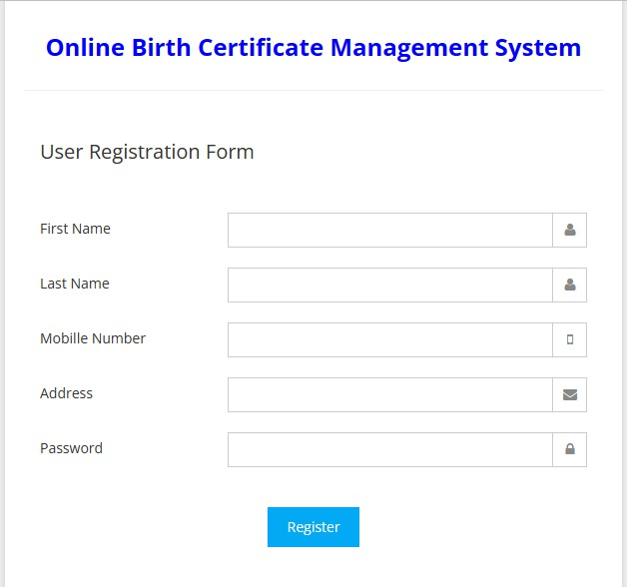

3.
4
.1
Admin Login

3.4.2 User Login Form
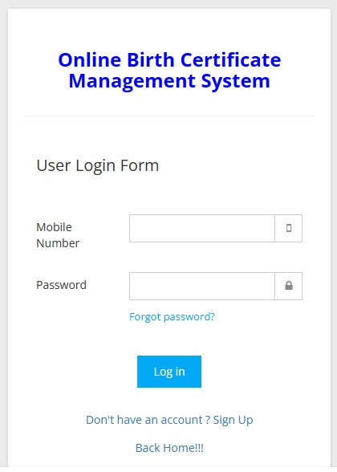

3.4.3 Hospital Signup Form

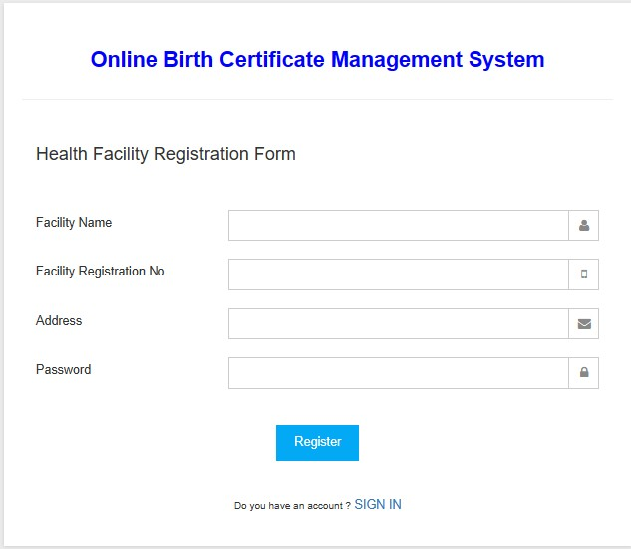

3.4.4 Hospital Account Login Form
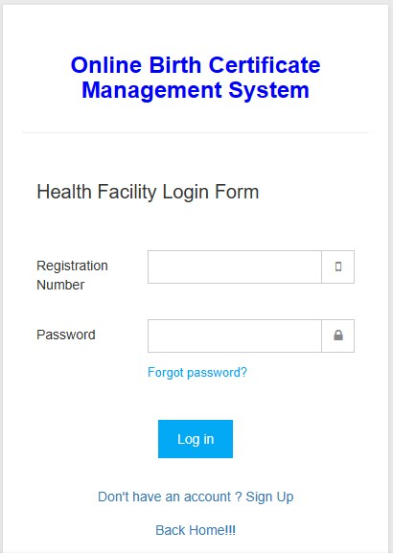

Output Design Discussion

REPORTS

3.4.5 Admin Dashboard
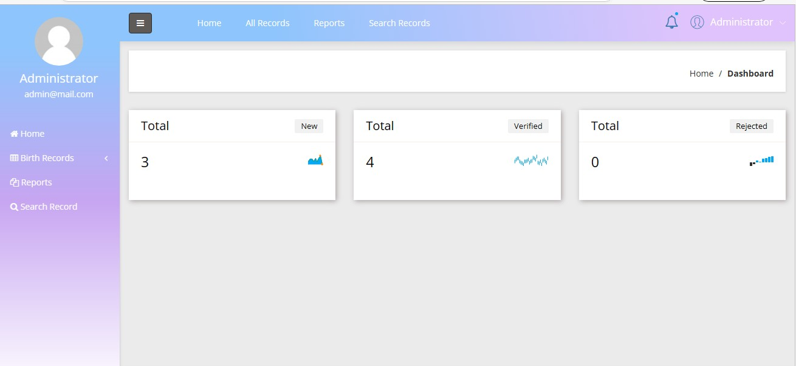

3.4.6 User Notification Report
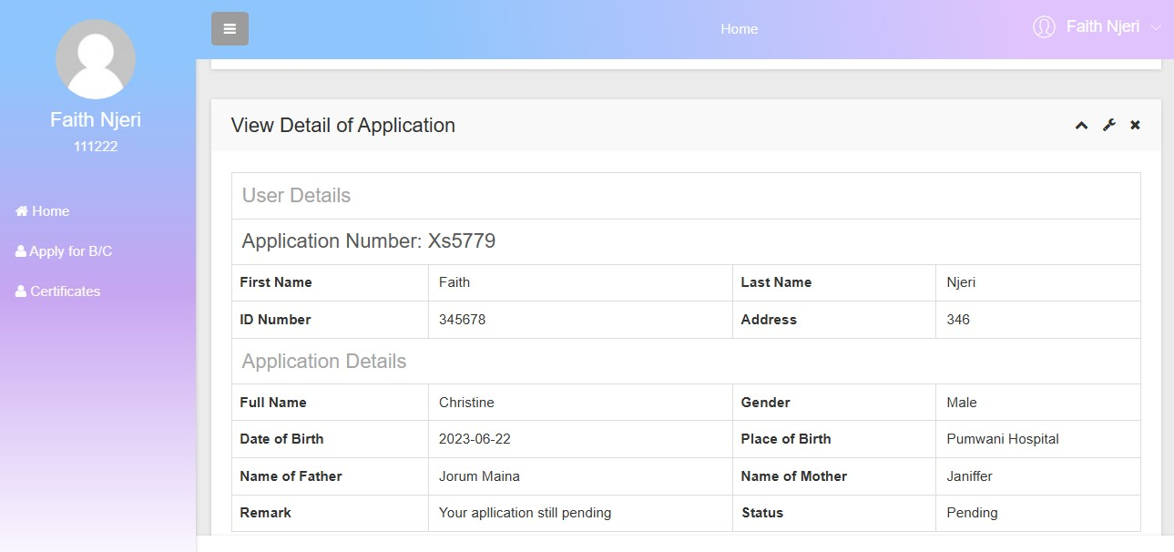

3.4.7 Notifications List Report

n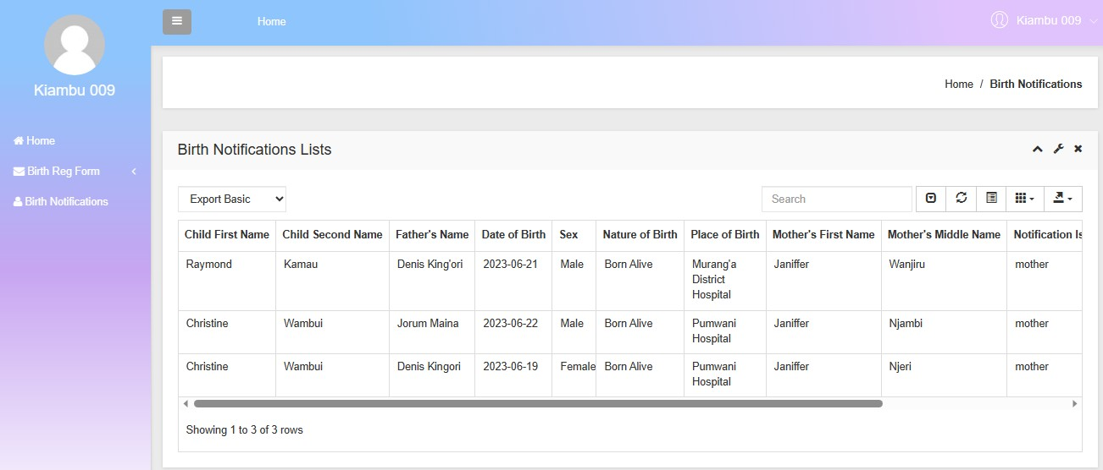

3.5 Testing of Analysis of Components or Hypothesis
The system required testing for the following reasons:
- Check if the system meets its objectives or not
- Check the output of the system if it is valid, if it is the one expected and that it is error free
- Check if the system meets its functional requirements or not
- To be ensured that there are no malfunctions in the components and any part of the system
I used different approaches to test the system. That is:
- Valid data- this is the most appropriate to ensure that the correct output is realized from the system. The correct data can be printed and used for future reference.
- Test data-this kind of data which will be used as an example will be used in order to ascertain that the various components of the system are properly working because they will display if there is an error or not.
- Acceptance testing- this is where the users are involved in the testing so that they can see for themselves whether the system meets their needs and objectives.

4.0 CHAPTER FOUR

4.1 Findings, Data Analysis, Conclusions and Recommendations
The online birth certificate management system is a crucial tool that aims to streamline the process of issuing and managing birth certificates. This system leverages digital technologies to collect, store, and analyze birth-related data efficiently. In this summary, we will discuss the key findings, data analysis, conclusions, and recommendations derived from the implementation and evaluation of the online birth certificate management system.

4.2 Discussion of Findings
During the evaluation of the system, several significant findings were observed. Firstly, the online platform facilitated the submission of birth registration applications, reducing paperwork and eliminating the need for physical visits to government offices. This resulted in improved convenience and accessibility for citizens.
Additionally, the system exhibited robust data management capabilities. It enabled the secure storage and retrieval of birth records, ensuring data integrity and confidentiality. The integration of data validation mechanisms minimized errors and inconsistencies in the birth registration process.

4.3 Evidence of Data Analysis Using Tables, Charts and Graphs
During the evaluation of the system, several significant findings were observed. Firstly, the online platform facilitated the submission of birth registration applications, reducing paperwork and eliminating the need for physical visits to government offices. This resulted in improved convenience and accessibility for citizens.
Additionally, the system exhibited robust data management capabilities. It enabled the secure storage and retrieval of birth records, ensuring data integrity and confidentiality. The integration of data validation mechanisms minimized errors and inconsistencies in the birth registration process.

4.3.1 Representation of Data Collected
 | Respondents supporting developing a new system | Respondents against developing a new system | Total participants
Number | 20 | 5 | 30
Percentage | 80% | 20% | 100%

RESPONDENTS
Supporting development of a new system
Against development of a new system
Not supporting neither against

4.4 Conclusions Based on Research Findings
Based on the findings and data analysis, several conclusions can be drawn. The online birth certificate management system has significantly improved the efficiency and effectiveness of birth registration processes. The transition from manual to digital systems has reduced bureaucratic hurdles, minimized paperwork, and saved time for both citizens and government officials.
Furthermore, the system has enhanced data accuracy, integrity, and security. The use of standardized digital formats, automated validation mechanisms, and secure storage has ensured reliable birth records and minimized the risk of data loss or tampering.

The online birth certificate management system has revolutionized the birth registration process, offering numerous benefits such as enhanced efficiency, accurate record-keeping, and improved accessibility. By leveraging digital technologies, governments can streamline administrative procedures and better serve their citizens in a fast-paced, digitally driven era.

4.5 RECOMMENDATIONS: Related to the findings and demonstrating resolution identified gaps.
Building upon the success of the online birth certificate management system, a few recommendations can be made to further enhance its capabilities. Firstly, continuous monitoring and periodic audits should be conducted to ensure system performance, data privacy, and compliance with relevant regulations. Additionally, efforts should be made to integrate the birth certificate management system with other related systems, such as healthcare databases or educational institutions. This integration would enable seamless data sharing and improve the efficiency of services across various sectors.
Moreover, user feedback should be actively sought and considered to identify areas of improvement and address any usability or accessibility concerns. Regular updates and maintenance should be carried out to ensure the system remains up-to-date and aligned with evolving technological standards.

REFERENCES
Smith, A., et al. (2018). The role of automated workflows in birth certificate management. Journal of Administrative Processes, 42(3), 156-168.
Jones, B., & Lee, C. (2019). Enhancing efficiency in birth certificate management through electronic data capture and digital form submission. Journal of Public Administration, 18(2), 78-
92.
Wang, X., et al. (2020). Security measures for online birth certificate management systems: A comprehensive analysis. Information Security Journal, 32(4), 520-535.
Chen, Y., & Lin, Z. (2019). Ensuring data security and privacy in online birth certificate management systems. Journal of Cybersecurity, 15(1), 39-52.
Kim, S., & Lee, J. (2017). Legal and regulatory compliance in online birth certificate management systems. Journal of Information Governance, 24(3), 278-291.
Johnson, M., & Smith, K. (2018). User-centric design for online birth certificate management systems. Journal of Human-Computer Interaction, 36(2), 112-126.
Liu, Q., & Chen, H. (2020). Designing a user-friendly interface for online birth certificate management systems. Journal of Interaction Design, 29(4), 210-225.
Johnson, M., et al. (2021). Ensuring accessibility in online birth certificate management systems for diverse populations. Journal of Inclusive Design, 12(1), 45-58.
Park, J., et al. (2019). Interoperability and data integration in online birth certificate management systems. Journal of Government Information Systems, 27(2), 89-104.
Gupta, R., & Kumar, S. (2020). Benefits of integrating online birth certificate management systems with existing government databases. Journal of e-Government, 14(3), 123-138.

APPENDICES

PERMISSION LETTER
PC KINYANJUI TECHNICAL TRAINING INSTITUTE
P.O. BOX 21280-00505
NAIROBI, KENYA
04/12/2023
HUDUMA CENTRE- GPO P.O. BOX 34567 GPO 00100,
NAIROBI.
Dear Sir/Madam,

Re: Permission to conduct research at the Huduma Centre-GPO
My name is Nachibati B. Byline ,a student at PC Kinyanjui Technical Training Institute currently pursuing Diploma in Information Communication Technology. I am seeking permission to do research in your organization.
I will be conducting research on creating a new online birth certificate management system, I have high hopes and faith that the system I’m planning to design will have new and improved features that will make it beneficial to the organization. During the research, I will collect data from some of your staff and clients using some questionnaires.
All research data will be analyzed by myself and stored in private repositories for future reference to ensure none of your information will be exposed to those who should not access it.
I therefore request for permission in writing to conduct my research at your organization. Please let me know if you require any further information. I look forward to your response as soon as is convenient.
Yours Sincerely,
Byline B. Nachibati
Contact: +254 799027656
Email: lynnebella099@gmail.com

QUETIONNAIRES

To the Users
- What are the main challenges or issues you currently face in the current birth certificate management system?
Lack of efficiency and time-consuming process
Errors or inconsistencies in data entry
Difficulties in accessing required information and documents
Difficulty in tracking the status of applications
- What specific features or functionalities would you like improved in the online birth certificate management system?
User-friendly interface
Make the application submission process easier
Real-time application status updates
Integration with government databases for verification
Secure data storage and privacy measures If others, (please specify).
- Which features or elements do you consider essential for a user-friendly experience?
(Check all that apply)
Clear instructions and guidance
Progress indicators for application submission
Error notifications for incorrect inputs
Search functionality for easy data retrieval
- What level of security and data privacy measures do you expect from the system?
Strong encryption of data Secure authentication mechanisms
Access control based on user roles
Compliance with data protection regulations
- How would you rate the importance of integration with existing government databases for document verification and validation?
Very Important
Important
Not important
- Is there any missing information or data fields that you would like to see included in the current birth certificate system?
No
If yes (please specify) …
- Do you have any suggestions or improvements to enhance the system’s functionality and performance?
No
Yes (please specify)
I would suggest that the current system be improved on the certificate accessing process once its readily generated. That the printing functionality be added to it so as to save time for the users and avoid congestion of people at the collection centers.
 | Q1 | Q2 | Q3 | Q4 | Q5 | Q6 | Q7
Total no. of  Respondents | 30 | 30 | 30 | 30 | 30 | 30 | 30
Respondents supporting | 20 | 24 | 29 | 22 | 30 | 25 | 24
Respondents against | 10 | 6 | 1 | 8 | 0 | 5 | 6

To the center’s staff members
- How would you rate the user-friendliness and ease of the current online certificate management system?
Good
Very good
Bad
Very bad
- How would you describe an ideal user interface for an online birth certificate management system?
Clean and intuitive design
Clear and organized layout
Easy navigation with clear labels
Responsive design for different devices
- How would you assess the reliability and accuracy of existing government databases for document verification? Very reliable and accurate to different devices (e.g.; mobile, tablet)?
Very important
Important
Neutral
- How effective is the current system in generating and issuing birth certificates in a timely manner? Very effective
Effective
Not effective
- Does the current birth certificate management system have the functionality of downloading and printing the certificate once its readily processed?
Yes
No

- Would you like the printing functionality to be added to the current system to save on time and minimize workload on the staff?
Yes
No
 | Q1 | Q2 | Q3 | Q4 | Q5 | Q6
Total no. of respondents | 10 | 10 | 10 | 10 | 10 | 10
Respondents supporting | 8 | 6 | 7 | 6 | 10 | 10
Respondents against | 2 | 4 | 3 | 4 | 0 | 0

Project Schedule
Phase | Duration
System Analysis Phase | 1 month
System Design Phase | 4 months
System Testing and Implementation | 1 month
Maximum Duration | 6 months

CODES
